**Big Mountain Resort Price recommendation**

**Recommendation:**

As per the data analysis and modelling performed on the provided resorts dataset, there definitely are possibilities to increase the ticket price. Even with the expected mean absolute error of $10.39, the modelling predicted ticket price to be $95.87 as compared to the existing price of $81 which suggest there is room for increase.

Out of the following scenarios provided by the business Scenario #2 seems most promising:

1. Permanently closing down up to 10 of the least used runs
2. Increase the vertical drop by adding a run to a point 150 feet lower down, but requiring the installation of an additional chair lift to bring skiers back up, without additional snow making coverage
3. Increase the vertical drop by adding a run to a point 150 feet lower down, but requiring the installation of an additional chair lift to bring skiers back up, adding 2 acres of snow
4. Increase the longest run by 0.2 mile to boast 3.5 miles length, requiring an additional snow making coverage of 4 acres

It shows to increase support for ticket price by $1.99, which over the season could be expected to amount to $3.47M (taking an assumption that on an average a visitor would buy 5 day tickets).

However, this would also incur the additional cost of the new chair lift per ticket and would have to be taken into account.

**Background:**

1. Data for all the states was taken into consideration for modelling and treated equally per the exploratory data analysis.
2. It was found that following datapoints had high correlation to the ticker price:

* Fast Quads
* Runs
* Snow Making area coverage
* Resort to Night skiing ratio
* Total chairs
* Vertical drop

1. Correlation between the AdultWeekend Price and the other features can be viewed through the following heatmap generated based on the dataset.

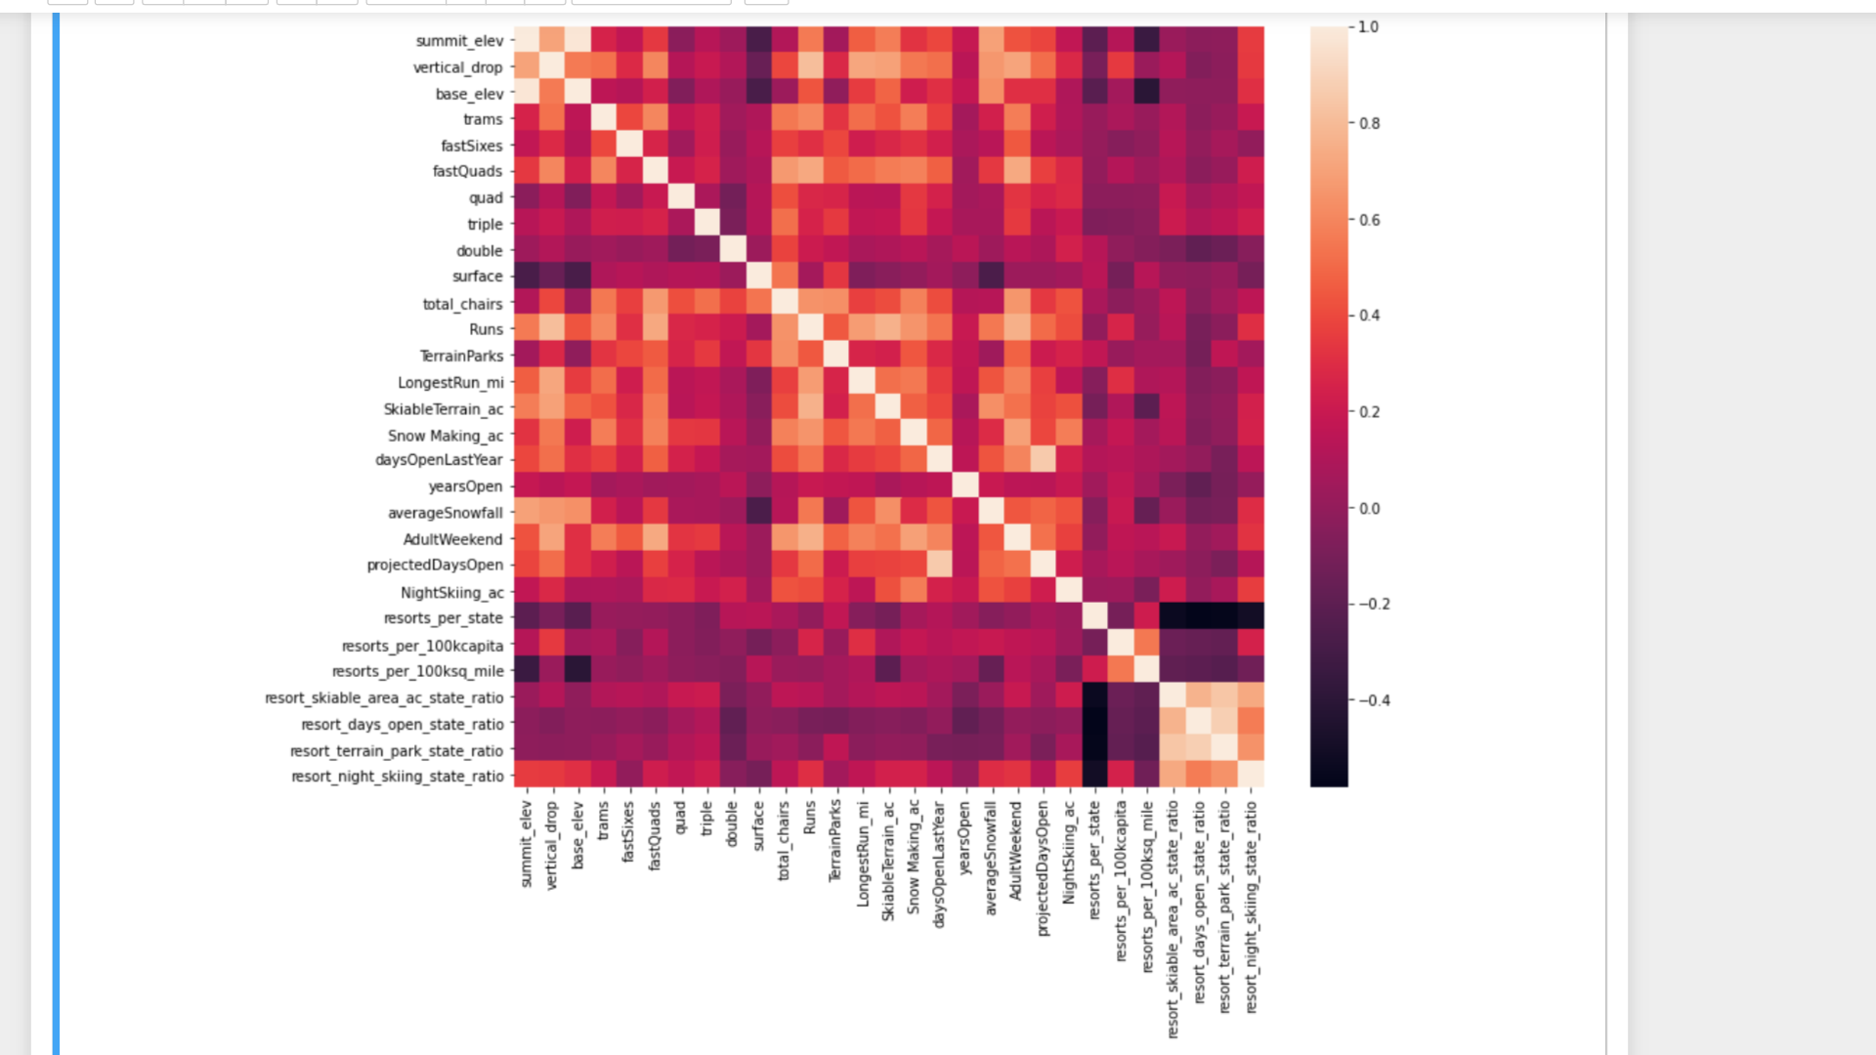

1. The data analysis showed that Big Mountain has amongst the highest number of total chairs.

Most resorts have no fast quads. Big Mountain has 3, which puts it high up that league table.

It has one of the longest runs and is amongst the resorts with the largest amount of skiable terrain.

Big Mountain is very high up the league table of snow making area. It is doing well for vertical drop, but there are still quite a few resorts with a greater drop.

1. Note: The validity of our model lies in the assumption that other resorts accurately set their prices according to what the market (the ticket-buying public) supports.
2. Having the data for annual visitors for each of the resorts can help further refine the prediction.